Spike: Task 11
Title: Game Graphs from Data
Author: Mohamed Shafi Uzman Fassy, 102608927

Goals / deliverables:
The goal of this spike task is to demonstrate my understanding of data structures ,reading and outputting from files that I have learnt from previous tasks in order to create a game world as a graph data structure.

Besides this report, what else was created?

- Code files in see

Technologies, Tools, and Resources used:
List of information needed by someone trying to reproduce this work.
- Visual Studio 2022 Community Edition
- GitHub
- Game Specification Details Canvas Module
- OO Concepts, Patterns & Structures Canvas Modules
  - 2.1 Software Architecture of Games Lecture Slides
  - 2.2 Game States and Stages Lecture Slides
  - 3.2 Data Structures
  - 3.3 Design Patterns
Tasks undertaken:
- Evaluating Different Data Structures for Inventory Systems
- Download and install Visual Studio
- Download and install Visual Studio C++ Debugging Packages
- Create and Configure VS Project File with a .cpp file to build.
- Creating Inventory and Item Class

What we found out:

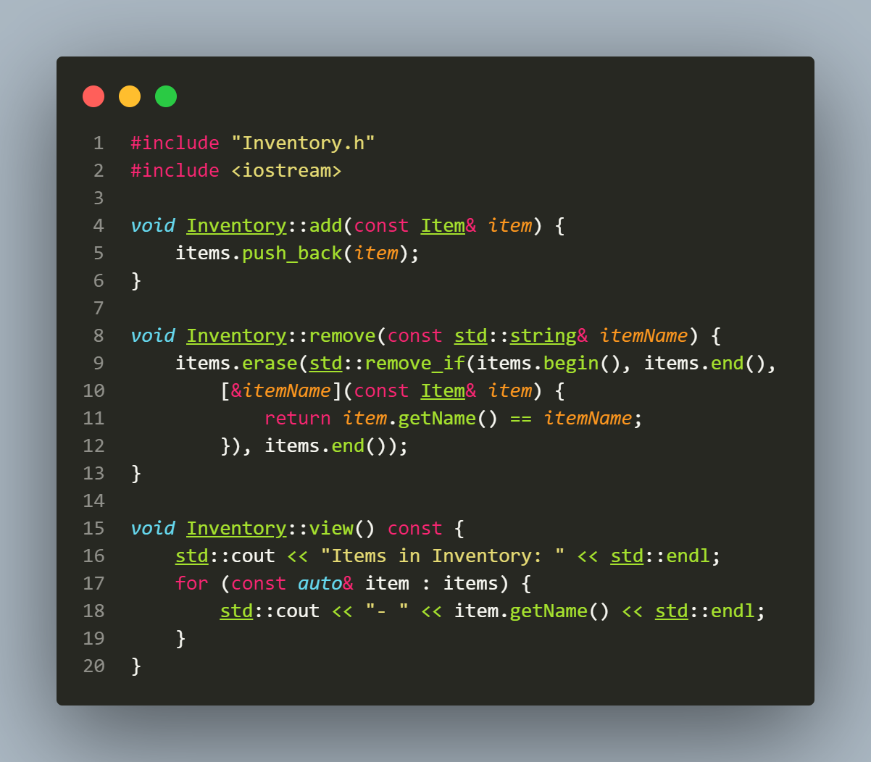
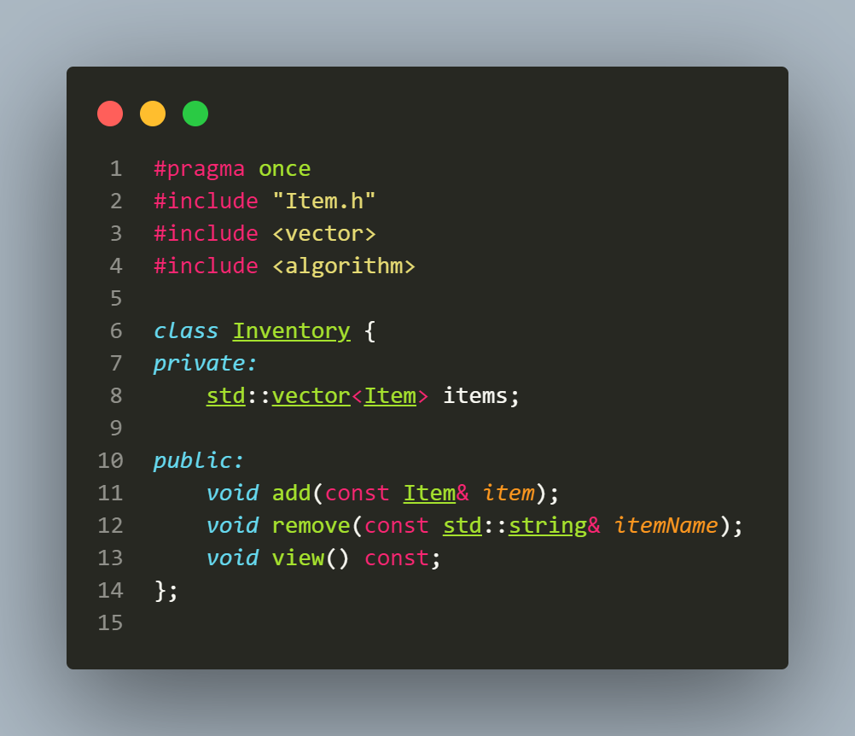
Implementing Inventory System

The Inventory class serves as the backbone for the inventory system. As the class is fundamentally designed to store, manage, and retrieve items that a player might possess during the gameplay.
Inventory Header File : the header file for the Inventory class, we declared the methods and properties associated with the inventory. Some of the primary methods such as:
- addItem(Item): that adds an item to the inventory.
- removeItem(Item): that removes a specific item from the inventory.
- displayItems(): that displays all the items currently held in the inventory.
To store the items, we use a std::vector data structure as this data structure was chosen due to its efficiency in appending and accessing elements, particularly if the order of items is significant.

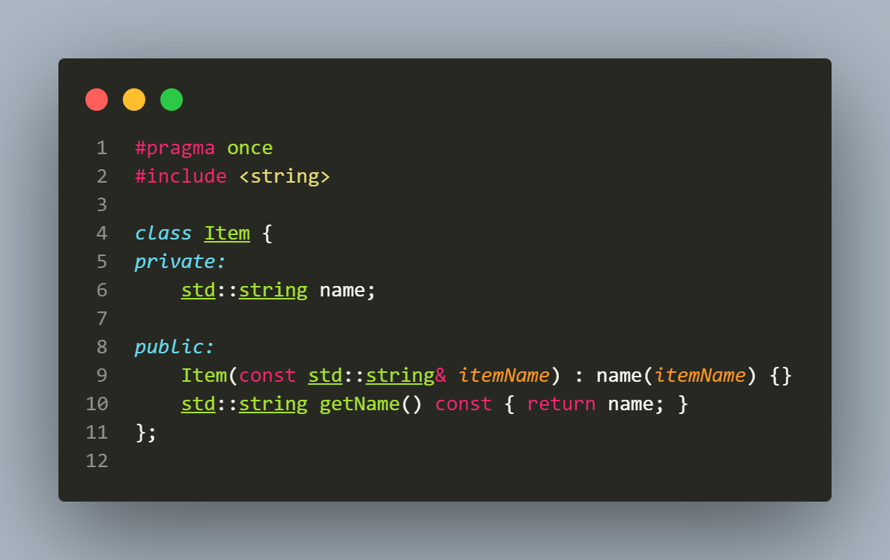
Implementing Item
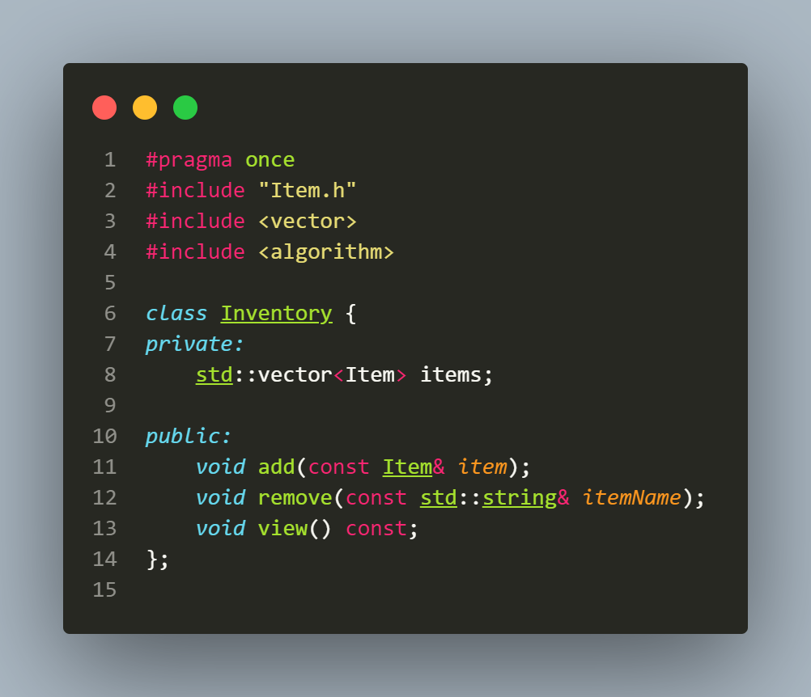
Item class represents individual item objects that can be added to or removed from the inventory. Each item uses an attribute such as a name to identify the item.
Item Header File: The item header file for the Item class outlines methods associated with individual items. Some fundamental methods and properties are:
- A constructor to initialize an item with specific attributes.
- Getter and Setter methods for each attribute.
- Perhaps methods that dictate how the item interacts with other game elements or the environment.

Testing Outcome
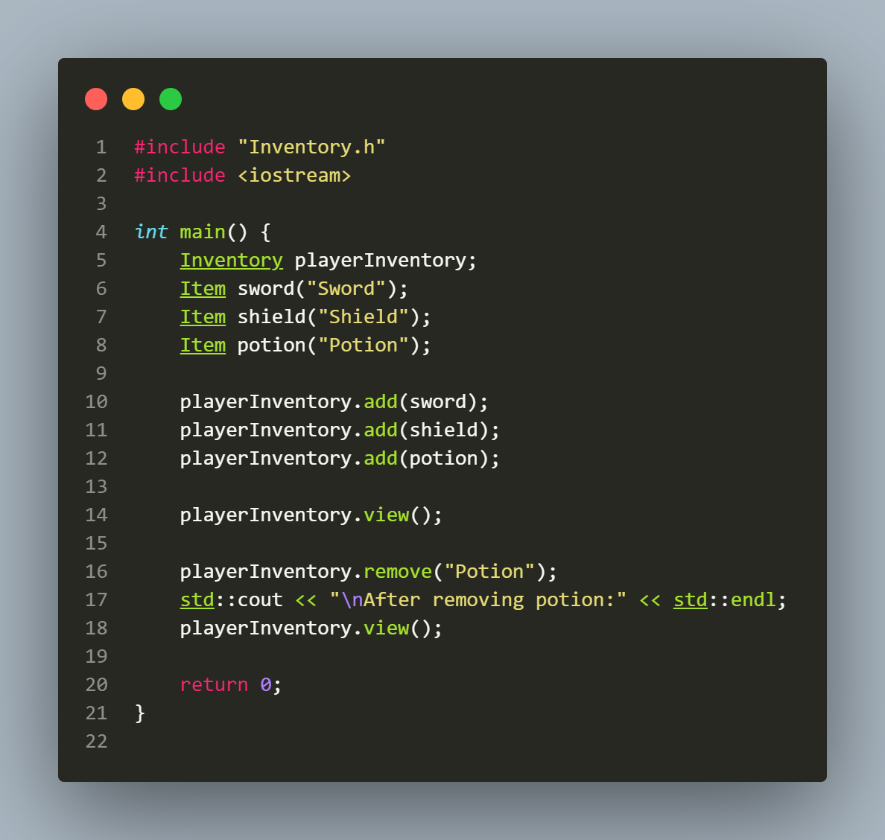
Once the Inventory class and Item class has been created, we did some testing in main where we created 3 items a sword, sheild and potion in which we added them to the inventory and then displayed then, after that we remove potion from the inventory and displayed the inventory again and it shows that the potion was removed from the inventory in real time.
